**Reading and Writing to a file**

Imports System.IO

Public Class frmFilePractice

Private openfile As FileStream 'needed to open the file

Private fileofstream As StreamReader 'used to read from the file

Private writefile As StreamWriter 'used to write to the file

Dim arrayline() As String 'used to store a line from the file

Dim lineoffile As String 'used to check that the line is not blank

Dim arraylength As Integer = 50 'used to set the length of the array

Dim numInFile = 0 'used to store the number in the file

Dim names(arraylength) As String 'array names

Dim ages(arraylength) As Integer 'array ages

Dim details As String

Private Sub Button1_Click(sender As Object, e As EventArgs) Handles btnAdd.Click

Try

'open the stream to write to a file

openfile = New FileStream("nameage.txt", FileMode.Append, FileAccess.Write)

writefile = New StreamWriter(openfile)

names(numInFile) = txtname.Text

ages(numInFile) = txtage.Text

writefile.WriteLine(names(numInFile) & "," & ages(numInFile))

numInFile += 1

'write each record to the file

For i = 0 To numInFile - 1

writefile.WriteLine(names(i) & "," & ages(i))

Next

'close the stream to the file

writefile.Close()

openfile.Close()

MessageBox.Show("File Updated on " & Now())

Catch ex As Exception

MessageBox.Show("Could not access file")

End Try

details = "Name" & vbTab & "Age" & vbNewLine

For i = 0 To numInFile - 1

details += names(i) & vbTab & ages(i) & vbNewLine

Next

MessageBox.Show(details)

End Sub

Private Sub frmFilePractice_Load(sender As Object, e As EventArgs) Handles MyBase.Load

'open the file and read the contents into the arrays

Try

'make a connection to the file

openfile = New FileStream("nameage.txt", FileMode.Open, FileAccess.Read)

'give fileofstream access to read from the file

fileofstream = New StreamReader(openfile)

For i = 0 To arraylength

'read the file line by line

lineoffile = fileofstream.ReadLine()

'check the line has data in it

If lineoffile IsNot Nothing Then

'add one to the numInFile

numInFile += 1

'split the line where there is a comma

arrayline = lineoffile.Split(","c)

'populate the arrays

names(i) = arrayline(0)

ages(i) = arrayline(1)

End If

Next

openfile.Close()

fileofstream.Close()

Catch ex As Exception

MessageBox.Show("Cannot access file")

End Try

End Sub

End Class

Test File

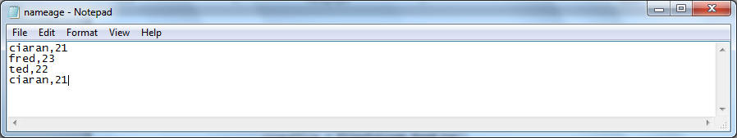

Form

